## **Activity Diagram**

***What is Use Activity Diagram?***

**Activity Diagram** is another important behavioral diagram in UML diagram to describe dynamic aspects of the system. Activity diagram is essentially an advanced version of flow chart that modeling the flow from one activity to another activity.

## **Purpose of Activity Diagrams**

The basic purposes of activity diagrams is similar to other four diagrams. It captures the dynamic behaviour of the system. Other four diagrams are used to show the message flow from one object to another but activity diagram is used to show message flow from one activity to another.

Activity is a particular operation of the system. Activity diagrams are not only used for visualizing the dynamic nature of a system, but they are also used to construct the executable system by using forward and reverse engineering techniques. The only missing thing in the activity diagram is the message part.

It does not show any message flow from one activity to another. Activity diagram is sometimes considered as the flowchart. Although the diagrams look like a flowchart, they are not. It shows different flows such as parallel, branched, concurrent, and single.

The purpose of an activity diagram can be described as:

* Draw the activity flow of a system.
* Describe the sequence from one activity to another.
* Describe the parallel, branched and concurrent flow of the system.

## **App Activity Diagram**

In our application, we have 3 actors, the admin (admin activity diagram ), the customer (customer activity diagram), and the visitor (Seller activity diagram ), and we will show the activity diagrams for each of them.

### Customer Activity Diagram:

Customer Activity Diagram part 1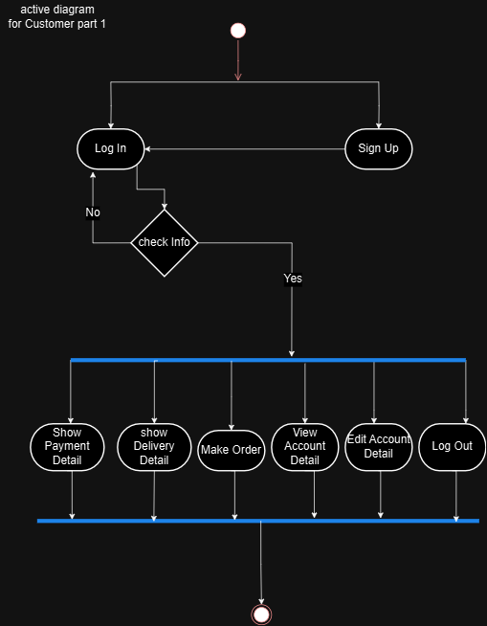

Customer Activity Diagram part 2

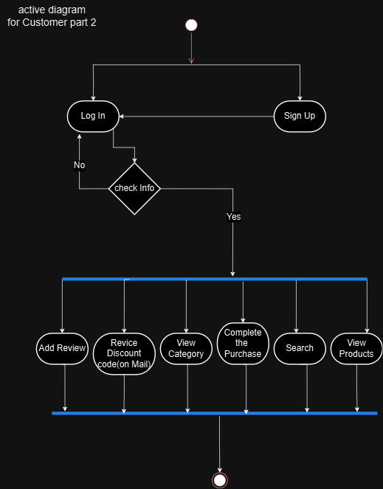

Customer Activity Diagram part 3

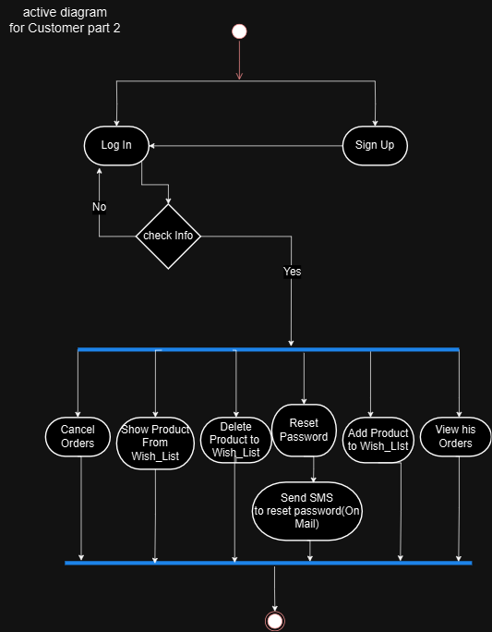

Customer Activity Diagram part 4

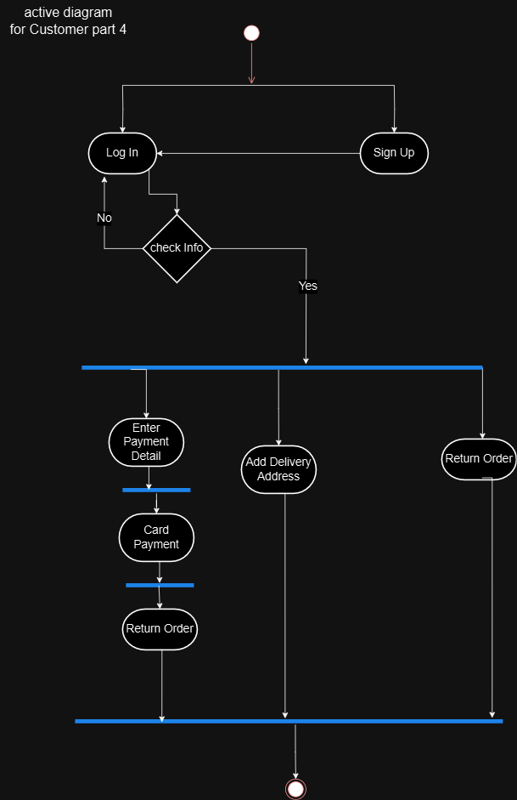

Admin Activity Diagram part 1

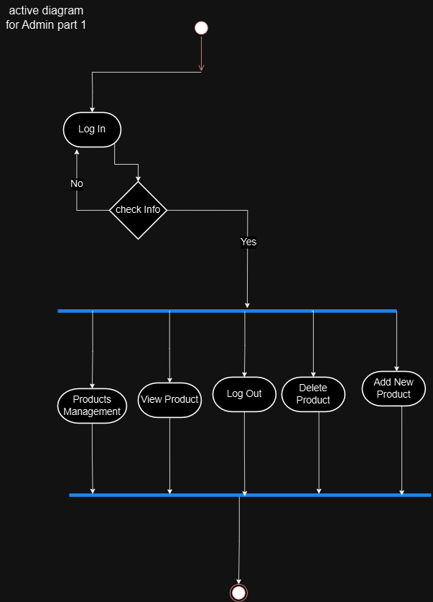

Admin Activity Diagram part 2

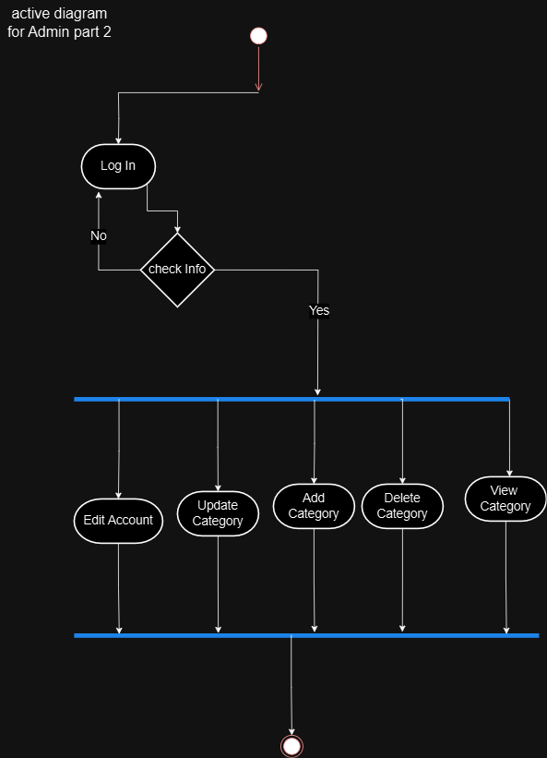

Admin Activity Diagram part 3

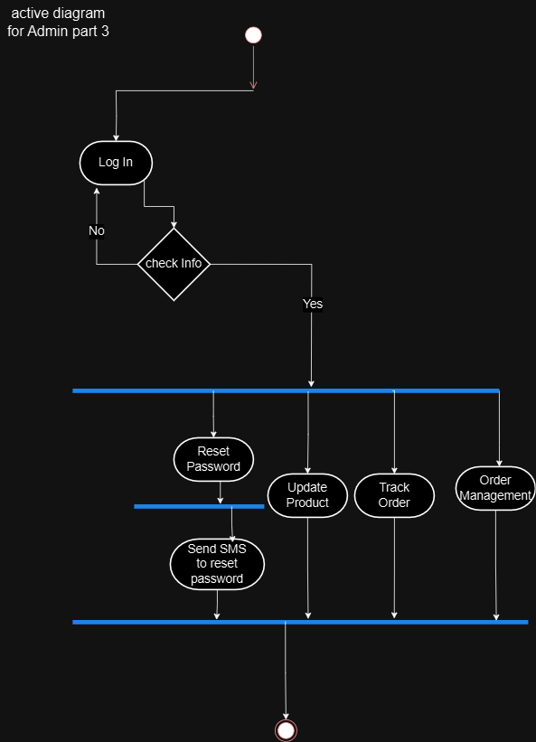

Seller Activity Diagram part 1

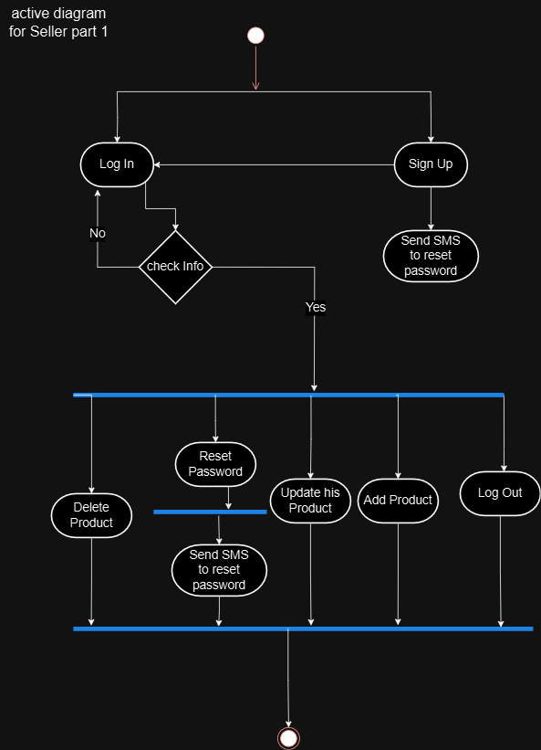

Seller Activity Diagram part 2

